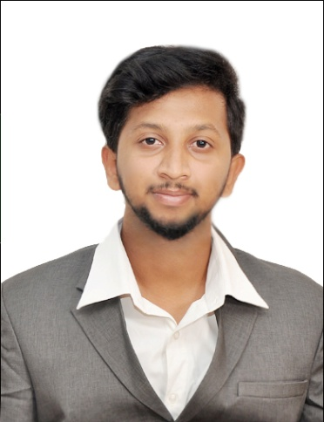



**RAGHUL THANGAVEL**

|  |  |
| --- | --- |
| **Portfolio** | **:** [raghulrage.github.io](https://raghulrage.github.io/) |
| **Email** | **:** [raghult2021@srishakthi.ac.in](mailto:raghult2021@srishakthi.ac.in) |
| **Mobile** | **:** +91-8428616811 |
| **LinkedIn** | **:** [linkedin.com/in/raghul](https://www.linkedin.com/in/raghul-thangavel-0b263b188/) |
| **Address** | **:** C-94, Cheran colony, Thudiyalur,  Coimbatore-641034 |

Looking for a challenging role in a reputable organization to utilize my technical, database, and management skills for the growth of the organization as well as to enhance my knowledge about new and emerging trends in the IT sector.

**ACADAMIC PROFICIENCY:**

|  |  |  |  |
| --- | --- | --- | --- |
| Course | Institution | Year of passing | Percentage of Marks |
| BE-Computer Science and Engineering | Sri Shakthi Institute of Engineering and Technology | Pursuing Third year | 7.47(Till 5th Semester)(CGPA) |
| **HSC** | AVB Matriculation Higher Secondary School, Coimbatore | 2017 | 88% |
| **SSLC** | AVB Matriculation Higher Secondary School, Coimbatore | 2015 | 97% |

**TECHNICAL PROFICIENCY:**

|  |  |
| --- | --- |
| **Software Tools** | Anaconda , Adobe Photoshop, JasperSoft Studio ,  Atom , Visual Studio |
| **Languages** | Python (Intermediate) ,  C programming (Basic) ,  PHP (Basic) |
| **Operating Systems** | Windows XP/7/8/8.1/10 / , Ubuntu Linux |
| **Web Technologies** | Html5, CSS3, JavaScript, Bootstrap |
| **Data structure & Development Algorithm** | MySQL (Intermediate),  Rest API (using PHP for CURD operation) |

**AREA OF INTEREST:**

* Data Analytics
* Photoshop
* Internet of Things
* Machine Learning
* Problem Solving
* Artificial Intelligence

**PROJECTS UNDERTAKEN:**

|  |  |  |  |  |
| --- | --- | --- | --- | --- |
| **PROJECTS** | **INSTITUTION** | **DESCRIPTION** | **MY ROLE** | **LINK** |
| **AGGREGATOR** | Boxigo LTD | A website to collaborate all packers and movers to provide service to the customers. | Worked as a backend-developer and as a graphic designer. | [boxigo.in](http://boxigo.in/) |
| WATER PURITY DETECTOR | Sri Shakthi Institute of Engineering & Technology (Autonomous) | An automated system for detecting water purity level and alert the authorized person when the water purity level decreases. (Using IOT) | Developed the entire project in  24 hours  (Hackathon) | [github/ Water-purity-detector](https://github.com/raghulrage/Water-purity-detector) |
| **KALAM** | Sri Shakthi Institute of Engineering & Technology (Autonomous) | A dynamic website for inter-college competition provides students to register in events. | Worked as a backend-developer and as a graphic designer. | [kalam.siet.ac.in](http://kalam.siet.ac.in/) |

**INTERNSHIP / INDUSTRIAL VISIT:**

**INTERNSHIP** at Ray’s technology at Bangalore (1 month)

**INDUSTRIAL VISIT** at Wipro Bangalore

**CERTIFICATIONS:**

Certified in Complete Python Bootcamp by Udemy

Completed Python Bootcamp in Udemy

**KEY STRENGTHS:**

* Providing overall leadership to the entire project team.
* Communicating with internal and external clients to determine specific requirements.
* Following the project life cycle like Agile and waterfall.

**ACHIEVEMENTS:**

* Organized Inter College Technical event (KALAM 2019) at Sri Shakthi Institute of Engineering & Technology
* Developed a website for a company, Boxigo
* Won Third prize in SIET Hackathon at Sri Shakthi Institute of Engineering & Technology (2019)
* Won Second prize in Logical Brain at Sri Shakthi Institute of Engineering & Technology (2019)
* Won Inter district Football tournament at AVB Matriculation Higher Secondary School (2016)

**PERSONAL PROFILE:**

**Date of Birth :** 25th June 1999

**Gender :** Male

**Father’s Name :** Thangavel P

**Mother’s Name :** Jeeva T

**Nationality :** Indian

**Hometown :** Coimbatore

**Languages Known :** English, Tamil

**Alternate Email :** [raghulrage@gmail.com](mailto:raghulrage@gmail.com)

**DECLARATION:**

I hereby declare that all the above information is true to the best of my knowledge.

Date: Signature

Place: (Name)